**MAHENDRA ENGINEERING COLLEGE FOR WOMEN**

**DEPARTMENT OF**

**INFORMATION TECHNOLOGY**



**PROFESSIONAL READINESS FOR INNOVATION, EMPLOYABILITY**

**AND ENTREPRENEURSHIP- IBM NALAIYA THIRAN**

**PROJECT REPORT**

**ON**

# “REAL-TIME COMMUNICATION SYSTEM POWERED BY AI FOR SPECIALLY ABLED”

**BACHELOR OF TECHNOLOGY IN**

**INFORMATION TECHNOLOGY**

|  |  |
| --- | --- |
| **DHIVYA R** | **(611419205007)** |
| **NANDHINI C** | **(611419205016)** |
| **SAVITHA S** | **(611419205030)** |
| **VIJAYA LAKSHMI R** | **(611419205041)** |

***Under the guidance of***

**Mr.A.K KARTHICK**

Assistant

Professor, Dept. of IT

# •

# ABSTRACT

The AI landscape today is dominated by purpose-built models deployed for dedicated tasks. But enterprises need a large corpus of labeled data, significant resources, and teams of skilled data scientists to train and maintain these models. Foundation models represent a generational opportunity for enterprise. They’re general-purpose, pre-trained models that can be fine-tuned to accomplish a wide set of tasks. We’re developing software, middleware, and hardware to bring frictionless, cloud-native development and use of foundation models to enterprise AI.

**1.INTRODUCTION:**

**1.1.Project Overview:**

In our society, we have people with disabilities. The technology is developing day by day but no significant developments are undertaken for the betterment of these people. Communications between deaf-mute and a normal person has always been a challenging task. It is very difficult for mute people to convey their message to normal people. Since normal people are not trained on hand sign language. In emergency times conveying their message is very difficult. The human hand has remained a popular choice to convey information in situations where other forms like speech cannot be used. Voice Conversion System with Hand Gesture Recognition and translation will be very useful to have a proper conversation between a normal person and an impaired person in any language.

The project aims to develop a system that converts the sign language into a human hearing voice in the desired language to convey a message to normal people, as well as convert speech into understandable sign language for the deaf and dumb. We are making use of a convolution neural network to create a model that is trained on different hand gestures. An app is built which uses this model. This app enables deaf and dumb people to convey their information using signs which get converted to human-understandable language and speech is given as output.

1. **2.Purpose:**

Artificial Intelligence has been opening up new and simpler ways to manage our daily activities. With the big potential to automate tasks that typically require human intelligence, such as speech and voice recognition, visual perception, predictive text functionality, decision-making and performance of a variety of other tasks, AI can help individuals with disabilities by making a major difference in their ability to get around and take part in the activities of daily living.

Artificial Intelligence can be a game-changer for disabled people by making it easier to create interactive tools that support physical accessibility and independence. Let’s go through some useful applications of Artificial Intelligence in this field and see how it can be used to improve the lives of those with disabilities in a number of ways

**2.LITRETURE SURVEY:**

**1.Existing System &**

**2.2.References:**

1. Based Real Time Communication for Physically and Speech Disabled People (Ong Chin Ann, Marlene Valeriu Lu – 2019)

Communication is a social process of exchanging information from one entity to another in verbal and nonverbal form. It defines our existence and it is an important instrument that connects people together. It comes naturally as a raw skill embedded in most people at birth and we acquired the ways of communication through cognitive learning. Communication is the basis, which drives the process of development in all the fields (Manohar, 2008) and it is the very core of our civilisation. The ability to communicate allows us to express emotion, feelings, convey our thoughts and ideas as well as to relate our experiences. It plays an important role in the dis semination of information and sharing of knowledge especially in the academic arena. Research has found that human started to learn how to communicate with each other since they are born not only through spoken and written languages but also body gesture, posture, facial expression and eye contacts (Busso, et al., 2004; Cohen, Grag & Huang, 2000).

2.Systemetic review of computer vision semantic analysis in medical (Antonio Victor Alencar Lundgren, Byron Leite Dantas Bezzerra – 2021)

Medical diagnosing techniques have fascinated us for a long time. It has been common for us to use them in our daily life and implement these technologies. Machine learning and especially computer vision contribute a lot in medical science, which make different difficult tasks easy for doctors and more tolerable for patients. They are widely useful in early detection of disease, and hence are a valuable tool to save human life. Cardio graphic techniques are a must for old age and infant safety.These include:• Retinoscopy - They although primitive in approach are a must once in a life time and retinoscopy have made yet successful to measure activities of rod and cone receptors in our eyes. Retina has three distinct areas for colors - erythrolabe, chlorolabe and cyanolabe…

3.A survey on Facial Emotion Recognition Techniques (Felipe Zago Canal, Tobias Rossi Muller, Gustavo Gino Scotton – 2022)

Facial expressions recognition is an ability to recognize people by their facial characteristic and differentiate it with one another. Human is born with the ability to recognize other people easily by identifying their facial features such as shape, appearance, skin texture and skin complexion. Other than that, humans also have the ability to express, interpret and differentiate facial expressions. The regular recur-ring ones are happiness, anger, disgust, fear, surprise and sad (Ekman & Friesen,1978). The six facial emotions stated above are important and play a major role in expressing emotion as well as recognising facial expression (Busso, et al, 2004).

3.A survey on Facial Emotion Recognition Techniques (Felipe Zago Canal, Tobias Rossi Muller, Gustavo Gino Scotton – 2022)

Facial expressions recognition is an ability to recognize people by their facial characteristic and differentiate it with one another. Human is born with the ability to recognize other people easily by identifying their facial features such as shape, appearance, skin texture and skin complexion. Other than that, humans also have the ability to express, interpret and differentiate facial expressions. The regular recur-ring ones are happiness, anger, disgust, fear, surprise and sad (Ekman & Friesen,1978). The six facial emotions stated above are important and play a major role in expressing emotion as well as recognising facial expression (Busso, et al, 2004).

4.Machine Learning based techniques in data analysis (Lavanya Vemulapalli, Dr.P.Chandra Sekhar – 2018) A lot more applications available for us in play store, app store, amazon, etc., which are dependent machine learning. There are significant number of organizations and startups which turn towards optimum machine learning, and have proved that investing in machine learning is the best in today’s world.It is an application from which we can virtually explore streets of cities. It uses a dense geosampling tool to shows the streets of cities. Streets are captured through a fleet of vehicles equipped with a specialized camera.

5. Survey on Machine Learning Algorithm’s (Rekha Nagar, Dr. Yudhvir Singh – 2022)

The subfield of artificial intelligence, machine learning has gained muchpopularity in last few couple of years. Many tech giants use machine learning algorithms, like Netflix’s algorithms to make movie prediction from your previous watched movies. In this section, we would like to present some of the famous algorithms which use frequently.They are:• Naïve-Bayes’ algorithm - This is the algorithm mostly used in machines and hardware. It simply applies Bayes’ theorem along with strong independence assumptions. Let’s take an example, to mark an email as spam, used for face detection software, etc.• K-means clustering algorithm - This is a type of unsupervised learning which has various uses including business and management. This algorithm also lets us know profit at each stage of the product. It is also referred as Lloyd’s algorithm. This algorithm is also used in grouping of features into different labels.Decision Trees - These are trees in which decisions are made by the computer at each stage based upon recurrence relations.

1. **3.Problem Statement Definition:**

|  |  |  |  |  |  |
| --- | --- | --- | --- | --- | --- |
| **Problem**  **Statement (PS)** | **I am** | **I’m trying to** | **But** | **Because** | **Which makes me**  **feel** |
| 1. Deaf and  Dumb peoples  can’t  communicate to normal people | Person with Hearing impairment | Convey my message to a normal people | They were not able to understand our gestures | They were not aware of the hand gestures used by us | Very difficult to convey and communicate with the normal people |
| 2. Normal people  not able to  communicate with PwD | Person who lives along  with a people of  PwD | Understand the messages  conveyed by the  PwD(dumb  and Deaf). | I can’t able to understand the  communication They were made  to me | I don’t know the meaning of the hand gestures they  use | Feels useless when I am not able to understand and not able to help them. |

**3.IDEATION & PROPOSED SOLUTION:**

**3.1. Empathy Map Canvas:**

[https://github.com/IBM-EPBL/IBM-Project-49596-](https://github.com/IBM-EPBL/IBM-Project-49596-1660828747/tree/main/Project%20design%20and%20planning/Ideation/empathy%20map/EMPATHY%20MAP)

[1660828747/tree/main/Project%20design%20and%20planning/Ideation/empathy%20map/EMPATHY%2 0MAP](https://github.com/IBM-EPBL/IBM-Project-49596-1660828747/tree/main/Project%20design%20and%20planning/Ideation/empathy%20map/EMPATHY%20MAP)

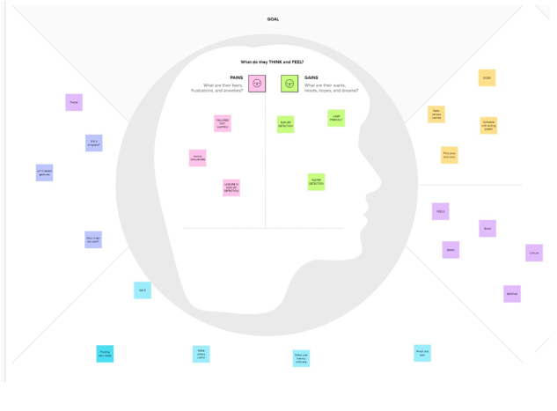

**3.2.Ideation and Brainstroming :**

[https://github.com/IBM-EPBL/IBM-Project-49596-](https://github.com/IBM-EPBL/IBM-Project-49596-1660828747/tree/main/Project%20design%20and%20planning/Ideation/brain%20strom%20and%20ideation)

[1660828747/tree/main/Project%20design%20and%20planning/Ideation/brain%20strom%20and%20ideat ion](https://github.com/IBM-EPBL/IBM-Project-49596-1660828747/tree/main/Project%20design%20and%20planning/Ideation/brain%20strom%20and%20ideation)

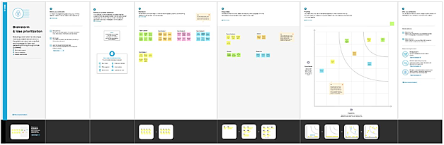

**3.3.Proposed Solution:**

|  |  |  |
| --- | --- | --- |
| **S.No.** | **Parameter** | **Description** |
| 1. | Problem Statement  (Problem to be solved) | To Develop a model which is very useful to communicate to normal people by using hand signal and gestures. |
| 2. | Idea / Solution description | 1. Using CNN model of image recognition to identify the accurate hand gestures 2. A quick result of voice and text after the gestures get identified |
| 3. | Novelty / Uniqueness | Image to sound detection is the uniqueness of this project. After analysing the hand signals the gesture get identified and provides a sound |
| 4. | Social Impact /  Customer Satisfaction | 1. Disabled people experience a great deal of difficulty with dayto-day activities 2. Normal people who not able to communicate with disabled peoples can now easily get communicate with them. It will be   the great impact and provide a satisfaction |

1. **4.Problem Solution:**

|  |  |  |
| --- | --- | --- |
| 1.CUSTOMER  SEGMENTS(CS) | 6.CUSTOMER CONSTRAINTS  (CC) | 5.AVAILABLE  SOLUTIONS(AS) |
| There were two customers:   1. Deaf and   Dumb People who can’t convey the message properly.   1. The normal People who are trying to communicate them were customers. | 1. Specially Abled Person use their hand signals to get communicate with other. 2. Normal people will face difficulty in understanding the sign language. | 1. CNN to identify the hand gestures. 2. AI to communicate   with gesture and voice Flask to develop application. |
|  |  |  |
| 2. JOBS TO BE DONE | 9. PROBLEM ROOT  CAUSE(RC) | 7. BEHAVIOUR(BE) |
| 1. Create an efficient app to convert hand gestures to voice and text. 2. Develop cnn model to recognize the voice and text. | 1. The Communication   barrier is root cause.   1. Problem of conveying message properly to the normal people. 2. The proper expression of the feel was not expressed | Searching the medium to express the feelings. Searching  a device to get translate. |
| • Developing and Training  the Dataset is major task |  |  |
|  |  |  |
| 3. TRIGGERS(TM) | 4. YOUR SOLUTION(SL) | 8.CHANNELS OF  BEHAVIOUR (CH) |
| The ability of the customers to communicate efficiently at serious and necessary situations. | This application help in communication between the normal people and dumb and  deaf people | The Application developed by us is the main channel of the behavior.  Online translation is also and Channel of Behaviour. |

**4.REQUIREMENTS & ANALYSIS**

1. **1.Functional Requirements:**

|  |  |  |
| --- | --- | --- |
|  | **Functional Requirement (Epic)** | **Sub Requirement (Story / Sub-Task)** |
| FR-1 | User Registration | **LOW VISION:**  As a user who has trouble reading due to low vision, I want to be able to make the text larger on the screen so that I can read it.  **Registration through Gmail** |
| FR-2 | User Confirmation | **IMPAIRED USER:**  As a user who is hearing -impaired, I want a turn on video captions so that I can understand what is being said in videos.  **Confirmation via Email** |
| FR-3 | User Registration | **COLOR BLINDNESS**:  As a user who is color blind, I want to links to be distinguishable on the page so that I can find the links and navigate the site.  **Registration through Gmail** |

1. **2.Non-Functional Requirements:**

Following are the non-functional requirements of the proposed solution.

|  |  |  |
| --- | --- | --- |
| **NFR**  **No.** | **Non-Functional Requirement** | **Description** |
| NFR-1 | **Usability** | 1. Visual and Audio Help 2. Text size scaling 3. Reverse contrast |
| NFR-2 | **Security** | Important information:   1. Walking in single file or in narrow space. 2. Steps, Stairs and Slope. 3. Kerbs and Roads. |
| NFR-3 | **Reliability** | To determine reliability measures are:   1. Test-Retest Repeatability 2. Individual Repeatability |
| NFR-4 | **Performance** | To determine predictors of success in reading with low vision aids, in terms of reading acuity, optimum acuity reserve, and maximum reading speed, for observers with low vision for various causes. |
| NFR-5 | **Availability** | Lack of adequate low vision services and barriers to their provision and uptake impact negatively on efforts to prevent visual impairment and blindness. |
| NFR-6 | **Scalability** | There is a large selection of device to help people with low vision. Some are “Optical”, glass lenses such as magnifying glasses and telescopes. |

**5.PROJECT DESIGN:**

**5.1.Data Flow Diagrams:**

A Data Flow Diagram (DFD) is a traditional visual representation of the information flows within a system. A neat and clear DFD can depict the right amount of the system requirement graphically. It shows how data enters and leaves the system, what changes the information, **Data Flow Diagram:**

**:**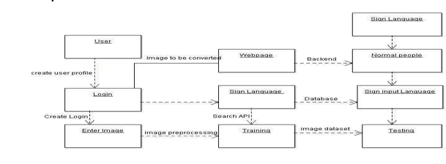

**5.2.Solution & Technical Architecture:**

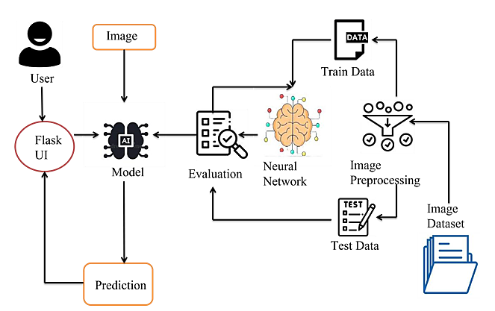

**5.3.User Stories:**

|  |  |  |  |  |  |  |
| --- | --- | --- | --- | --- | --- | --- |
| **User Type** | **Functional**  **Requirement**  **(Epic)** | **User**  **Story**  **Number** | **User Story / Task** | **Acceptance**  **criteria** | **Priority** | **Release** |
| Customer (Low  vision) | Registration | USN-1 | As a user, who has trouble reading due to low vision, I want to be able to make the text larger on the screen so that I can read it. | I can access my account / dashboard | High | Sprint-1 |
| Customer (Color blindness) |  | USN-2 | As a user, who is color blind ,I want to have access to information conveyed in color so that, I do not miss anything and I understand the content. | I can receive confirmation  email & click  confirm | High | Sprint-1 |
| Customer (Impaired user) |  | USN-3 | As a user, who is hearing-mpaired, Iwant a transcript of the spoken audio so that I can have access to all information provided in audio clips | I can register & access the dashboard with  Facebook  Login | Low | Sprint-2 |

**6.PROJECT PLANNING & SCHEDULING:**

1. **1.Sprint Planning & Explanation:**

|  |  |  |  |  |
| --- | --- | --- | --- | --- |
| **TITLE** | **DESCRIPTION** | **DATE** |  | **ACHIEVEMENT** |
| **Literature**  **Survey &**  **Information**  **Gathering** | Literature survey on the selected project & gathering information by referring the, technical papers, research publications etc. | 20  September  2022 | •  • | Referring to **the previous findings made to understand the drawbacks that are present in the app.**    Able to **understand the technologies and methods used** in building of the system. |
|  |  |  | • | **Helped us to know what would be the output if a technology is used.** |
| **Prepare**  **Empathy Map** | Prepare Empathy Map  Canvas to capture the user Pains & Gains, Prepare list  of problem statements | 20 October  2022 | 1. Empathy map   enabled us **to gather all the ideas at one single place.**     1. Successfully segregated the **pros, cons,**  **public opinion and time required for building of the app** and other factors clearly.        1. **Very helpful when we were at the scratch.** | |
| **Ideation** | List the by organizing the brainstorming session and  prioritize the top 3 ideas  based on the feasibility & importance. | 20 October  2022 | 1. Brainstorming session enabled us to **join together and collectively give various ideas** to solve existing problem.      1. Based on the priority, **best ideas to implement and booming technologies suggested were plotted in the graph** for clear cut understanding. | |

|  |  |  |  |
| --- | --- | --- | --- |
| **TITLE** | **DESCRIPTION** | **DATE** | **ACHIEVEMENT** |

|  |  |  |  |
| --- | --- | --- | --- |
| **Proposed Solution** | Prepare the proposed solution document, which includes the novelty, feasibility of idea, business model, social impact, scalability of solution, etc. | 21 October 2022 | Once the ideation was finished, we as team now **decided our own solution in order to solve the existing problem.**      Document made on the Problem statement, customer satisfaction and uniqueness made to **understand the core of the existing problem, much better.** |
| **Problem Solution Fit** | Prepare problem - solution fit document. | 21 October 2022 | Similar to ideation, where we were actually **thinking on the side of user and noted the pros, cons, issues faced in using the app.**    **Pointed out the triggers and**  **problem root cause**  **and also the available solutions** that reduce the effects of their inability.      See that, **the proposed solution can be a bonanza besides the available solution** to the disabled. |
| **Solution Architecture** | Prepare solution architecture document. | 21 October  2022 | 1. In this phase , we as a team made an architecture diagram which would describe the role performed by admin, end user and the the operations being performed.      1. **The operations involved in the proposed solution are briefed** in this diagram. |

|  |  |  |  |
| --- | --- | --- | --- |
| **TITLE** | **DESCRIPTION** | **DATE** | **ACHIEVEMENT** |
| **Customer Journey** | Prepare the customer journey maps to understand the user interactions & experiences with the application (entry to exit). | 21 October 2022 | Listed different factors like  **Research, Comparison with others, working condition of the app, questioning and sign out.**    It made to **understand the customer’s point of view precisely** before , at present and after using the app. |
| **Functional Requirement** | Prepare the functional requirement document. | 21 October 2022 | **Stated the software and hardware requirements** required from user’s side in order to use the app.    Also **mentioned**  **the specifications and the functionalities** |

|  |  |  |  |
| --- | --- | --- | --- |
|  |  |  | required to use the app. |
| **Data Flow Diagrams** | Draw the data flow diagrams and submit for review. | 21 October 2022 | DFD is constructed in order to **understand the start and end process of app usage.**    Also, **mentioned the user stories along with their sprints** to determine the amount of time required in implementing the particular sprint. |
| **Technology Architecture** | Prepare the technolo gy architecture diagram. | 21 October 2022 | **Given a detailed mindblowing architecture where all the technologies are used and also the sequential process** from start to end.    **Sample outputs provided enriched the quality and importance** of using the app. |
| **Prepare Milestone &**  **Activity List** | Prepare the milestones & activity list of the project. | 22 October 2022 | Made us to **list the achievements obtained in each and every phase.**    Made us to **feel good and confident to move forward towards development phase.** |

|  |  |  |  |
| --- | --- | --- | --- |
| **Project Development -**  **Delivery of Sprint-1, 2, 3**  **& 4** | Develop & submit the developed  code by testing it. | IN  PROGRESS… | Entire development phase is **divided into four sprints.**    **Design and build** each and every module . |

**6.2.Sprint Delivery Schedule:**

[**https://github.com/IBM-EPBL/IBM-Project-49596-**](https://github.com/IBM-EPBL/IBM-Project-49596-1660828747/blob/main/Project%20design%20and%20planning/Project%20planning/Sprint%20Delivery%20Plan.pdf)

[**1660828747/blob/main/Project%20design%20and%20planning/Project%20planning/Sprint%20De livery%20Plan.pdf**](https://github.com/IBM-EPBL/IBM-Project-49596-1660828747/blob/main/Project%20design%20and%20planning/Project%20planning/Sprint%20Delivery%20Plan.pdf)

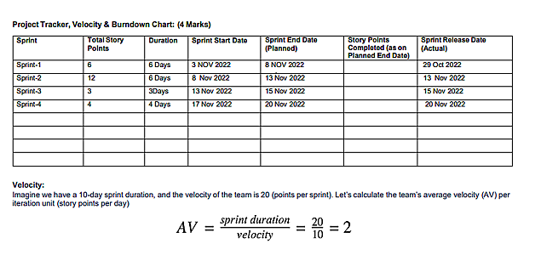

**6.3.REPORTS FROM JIRA**

JIRA Software is part of a family of products designed to help teams of all types manage work**.** It can be accepted as an task scheduler which describes the To-do, In-Progress and Done tasks.

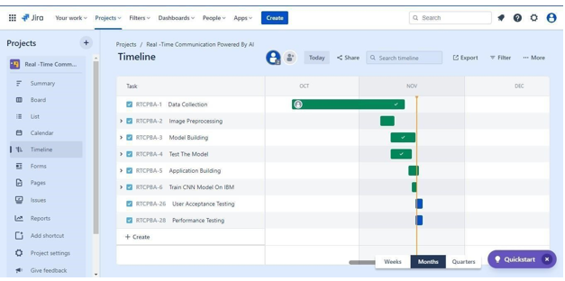

**7.CODING & SOLUTIONING:**

**7.1 Detection of Hand Signals Clearly :**

|  |
| --- |
| def detect(jpeg): img = resize(jpeg, (64, 64, 3))  copy = img.copy()  copy = copy[150:150 + 200, 50:50 + 200] cv2.imwrite('image.jpg', copy)    copy_img = image.load_img('image.jpg') x = image.img_to_array(copy_img) x = np.expand_dims(x, axis=0) prediction = np.argmax(model.predict(x), axis=1) pred = vals[prediction[0]] print("it indicates :  ", pred) return pred |

1. **2.Getting the Results From HTML Page:**

|  |  |
| --- | --- |
| <!DOCTYPE html>  <html>  <head>  <title>html page</title> |  |
| </head>  <body>  <h1>video streaming</h1>  <img id="video" src="{{ url_for('video_feed') }}">  </body>  </html> |  |
|  |

**7.3.Reading Live Stream Frame Using Python code with Clear Pixels:**

|  |  |
| --- | --- |
| while True: frame = video_camera.get_frame()  if frame != None: global_frame = frame yield (b'--frame\r\n' b'Content-Type: image/jpeg\r\n\r\n' + frame + b'\r\n\r\n') else:  yield (b'--frame\r\n'  b'Content-Type: image/jpeg\r\n\r\n' + global_frame + b'\r\n\r\n') |  |
|  |

**8.TESTING:**

**1.Purpose of Document**

The purpose of this document is to briefly explain the test coverage and open issuesof the project at the time of the release to User Acceptance Testing (UAT

**2.Test Case Analysis**

This report shows the numberof test cases that have passed, failed,and untested

|  |  |  |  |  |
| --- | --- | --- | --- | --- |
| **Section** | **Total**  **Cases** | **Not Tested** | **Fail** | **Pass** |
| Camera detection | 1 | 0 | 0 | 1 |
| Train the model and saving | 7 | 0 | 0 | 7 |
| Frame capturing and output | 2 | 0 | 2 | 0 |

**9.PERFORMANCE TESTING:**

|  |  |  |  |
| --- | --- | --- | --- |
| S.No. | Parameter | Values | Screenshot |
| 1. | Project structure | PYTHON FILE  HTML FILE  FLASK APP  LOADED MODEL |  |
| 2. | OUTPUT | Camera enable and le er display |  |

**10.ADVANTAGES & DISADVANTAGES:**

**ADVANTAGES:**

1. Main advantage is normal people can easil communicate to PwD.
2. PwD people can easily express their feelings to everyone

**DISADVANTAGES**

1. Lack of knowledge on using the application
2. Working under low light camera may be a disadvantages.

**11.CONCLUSION:**

To Develop a model which is very useful to communicate to normal people by using hand signal and gestures Disabled people experience a great deal of difficulty with day-to-day activities Normal people who not able to communicate with disabled peoples can now easily get communicate with them. It will be the great impact and provide a satisfaction.. A person who needs this model can afford at low price and this provide a income. This advanced technology make life easier and will get great demand in market of technology.

1. **FUTURE SCOPE**

o A new module can be developed that working under low light condition. o CNN algorithm can be tuned more to get an accurate result that desired.

**12.APPENDIX:**

**Source Code:**

**#webstreaming.py**

|  |
| --- |
|  |
| import numpy as np import cv2 import os from keras.models import load_modelfrom flask import Flask, render_template, Response, jsonify, request from camera import  VideoCamera from keras.preprocessing import image  global graph global writer from skimage.transform import resize |

|  |  |  |
| --- | --- | --- |
|  | writer = None model = load_model('Balaji.h5') vals = ['A', 'B', 'C', 'D', 'E', 'F', 'G', 'H', 'I'] app = Flask(__name__) print("[info] accessing video stream...") vs = cv2.VideoCapture(0)  def detect(jpeg): img = resize(jpeg, (64, 64, 3))  copy = img.copy()  copy = copy[150:150 + 200, 50:50 + 200] cv2.imwrite('image.jpg', copy) copy_img = image.load_img('image.jpg') x = image.img_to_array(copy_img) x = np.expand_dims(x, axis=0) prediction = np.argmax(model.predict(x), axis=1) pred = vals[prediction[0]] print("it indicates : ", pred) return pred  video_camera = None global_frame = None  @app.route('/') def index():  return render_template('index.html')  def gen(): global video_camera global global_frame  if video_camera == None: video_camera = VideoCamera()  while True: frame = video_camera.get_frame()  if frame != None:  global_frame = frame yield (b'--frame\r\n' b'Content-Type: image/jpeg\r\n\r\n' + frame + b'\r\n\r\n') else:  yield (b'--frame\r\n'  b'Content-Type: image/jpeg\r\n\r\n' + global_frame + b'\r\n\r\n') img = resize(frame, (64, 64)) |  |
|  | x = image.img_to_array(img) x = np.expand_dims(x, axis=0)  prediction = np.argmax(model.predict(x), axis=1)  pred = vals[prediction[0]] print("it indicates : ", pred)  @app.route('/video_feed') def video_feed(): return Response(gen(), mimetype='multipart/x-mixed-replace; boundary=frame')  if __name__ == '__main__': app.run(host='0.0.0.0', debug=True) |  |

**#camera.py**

|  |
| --- |
| import cv2  class VideoCamera(): def __init__(self): # Open a camera  self.cap = cv2.VideoCapture(0)  def __del__(self): self.cap.release()  def get_frame(self): ret, frame = self.cap.read()  if ret:  ret, jpeg = cv2.imencode('.jpg', frame) return jpeg.tobytes()  else:  return None |

**#index.html**

|  |  |
| --- | --- |
| <!DOCTYPE html>  <html>  <head>  <title>html page</title>  </head>  <body>  <h1>video streaming</h1>  <img id="video" src="{{ url_for('video_feed') }}">  </body>  </html> |  |
|  |

**#train.ipynb**

**#%%**

**from keras.preprocessing.image import ImageDataGeneratortrain_datagen = ImageDataGenerator(rescale = 1./225,**

**shear_range=0.2,zoom_range=0.2,horizontal_flip=True)test_datagen = ImageDataGenerator(rescale = 1./225)**

**#%%**

**x_train =**

**train_datagen.flow_from_directory('Dataset/training_set',target_size=(64,64),**

**batch_size=300,class_mode='categorical', color_mode ="grayscale")**

**#%%**

**x_test =**

**train_datagen.flow_from_directory('Dataset/test_set',target_size=(64,64),**

**batch_size=300,class_mode='categorical', color_mode ="grayscale")**

**#%%**

**from keras.models import Sequentialfrom keras.layers import Densefrom keras.layers import Convolution2Dfrom keras.layers import MaxPooling2Dfrom keras.layers import Dropout**

**from keras.layers import Flatten**

**#%%**

**model=Sequential()**

**#%%**

**model.add(Convolution2D(32,(3,3), input_shape=(64,64,1), activation =**

**'relu'))**

**#%%**

**model.add(MaxPooling2D(pool_size=(2,2)))**

**#%%**

**model.add(Flatten())**

**#%%**

**model.add(Dense(units=512,activation='relu'))**

**model.add(Dense(units=9,activation='softmax'))**

**#%%**

**model.compile(loss='categorical_crossentropy', optimizer='adam', metrics=['accuracy'])**

**#%%**

**model.fit_generator(x_train, steps_per_epoch=24,**  **epochs=10,validation_data=x_test,validation_steps=40)**

**#%%**

**model.save('Dhanish.h5')**

**#test.ipynb**

from keras.models import load_model import numpy as np import cv2 model=load_model('Balaji.h5')

from skimage.transform import resize def detect(frame):

img = resize(frame,(64,64,1)) img = np.expand_dims(img,axis=0)

if(np.max(img)>1):

img = img/255.0

prediction = model.predict(img)

print(prediction)

predictions = np.argmax(model.predict(img), axis=1)

print(predictions[0])

frame=cv2.imread(r"E:\Development\Dataset\test_set\B\1.png") data= detect(frame)

**Github link:**

https://github.com/IBM-EPBL/IBM-Project-49596-1660828747

**DEMO LINK**:

https://drive.google.com/file/d/102b22aohkDfxF7k5ZEKGBbLfrx8jRBvg/view?usp=drivesdk